1. **Pemodelan *Use Case* Diagram**

Berikut ini adalah *Use Case* Diagram yang menggambarkan (Penerapan system .SIPAK) yaitu pengelolaan pada level Staff desa dan level user, berikut gambarannya:

* 1. **Use Case Diagram**

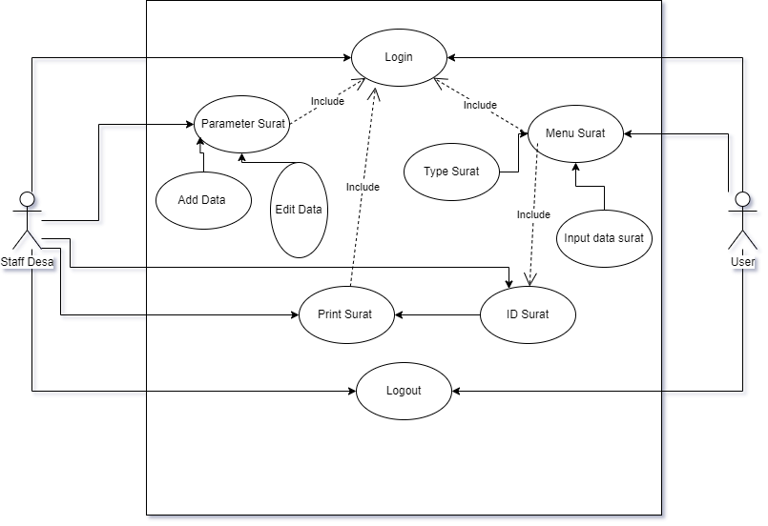

Gambar x.x Usecase Diagram Sistem SIPAK

Tabel Deskripsi Use Case Diagram Staff Desa membuat parameter surat

|  |  |
| --- | --- |
| ***Use Case Name*** | Parameter Surat |
| ***Use Case Description*** | Pengguna, jika ingin membuat parameter surat harus login terlebih dahulu dan menuju ke menu parameter surat lalu klik add data parameter surat setelah selesai lalu di simpan. |
| ***Actors*** | Pengguna |
| **Pre-Conditions** | Sistem harus terhubung ke jaringan internet  Masuk ke menu parameter surat  Input semua isian parameter surat |
| ***Post-Conditions*** | Jika Sudah mengisi seluruh isian, selanjutnya system akan menyimpanya dalam database |
| ***Failed and condition*** | 1. Jika login akun tidak sesuai , system akan  menolak dan proses selesai  2. Jika inputan tidak di simpan, system tidak dapat  menyimpan data |

Tabel Deskripsi Use Case Diagram *Login*

|  |  |
| --- | --- |
| ***Use Case Name*** | *Login* |
| ***Use Case Description*** | Staff Desa dan User dapat masuk kedalam system untuk  mengakses fungsionalitas system *Login* |
| ***Actors*** | Staff Desa dan User |
| **Pre-Conditions** | Sistem harus terhubung ke jaringan internet  Mengakses form *Login*  Memasukan usename dan password |
| ***Post-Conditions*** | Jika Validasi sesuai dan *Login* berhasil, pesan berhasil ditampilkan, actor bisa mengakses masuk kedalam  system |
| ***Failed and condition*** | Jika validasi tidak sesuai, sistem akan menolak dan proses selesai. |

Tabel Deskripsi Use Case Diagram *Menu surat*

|  |  |
| --- | --- |
| ***Use Case Name*** | Menu surat |
| ***Use Case Description*** | Menu surat di akses oleh user untuk mengisi form surat |
| ***Actors*** | user |
| **Pre-Conditions** | Sistem harus terhubung ke jaringan internet  Mengakses form *Login*  Memasukan usename dan password  Mengakses menu surat  Input data menu surat yang dipilih |
| ***Post-Conditions*** | Jika menu surat sudah di input sesuai type surat yang di pilih maka data akan disimpan dalam database |
| ***Failed and condition*** | Jika data yang di input kurang atau Jika inputan tidak di simpan maka system tidak dapat menyimpan data |

* 1. **Activity diagram login**

Gambar 4.2 Activity diagram login

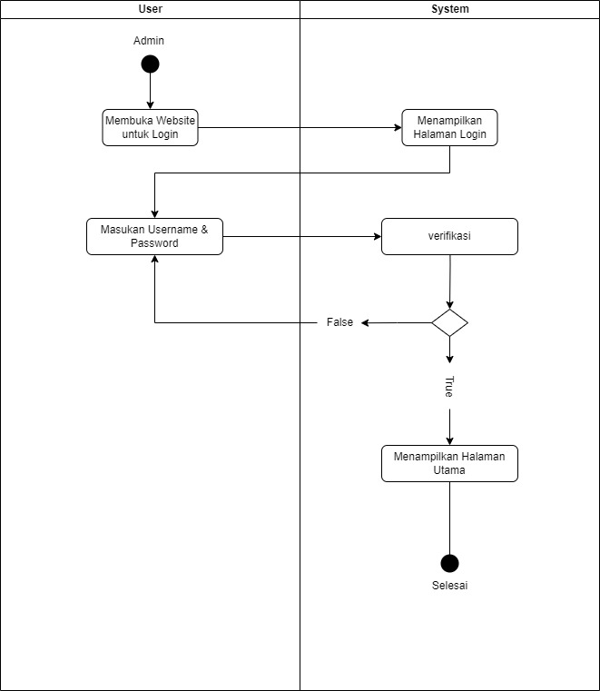

## Activity diagram membuat parameter surat

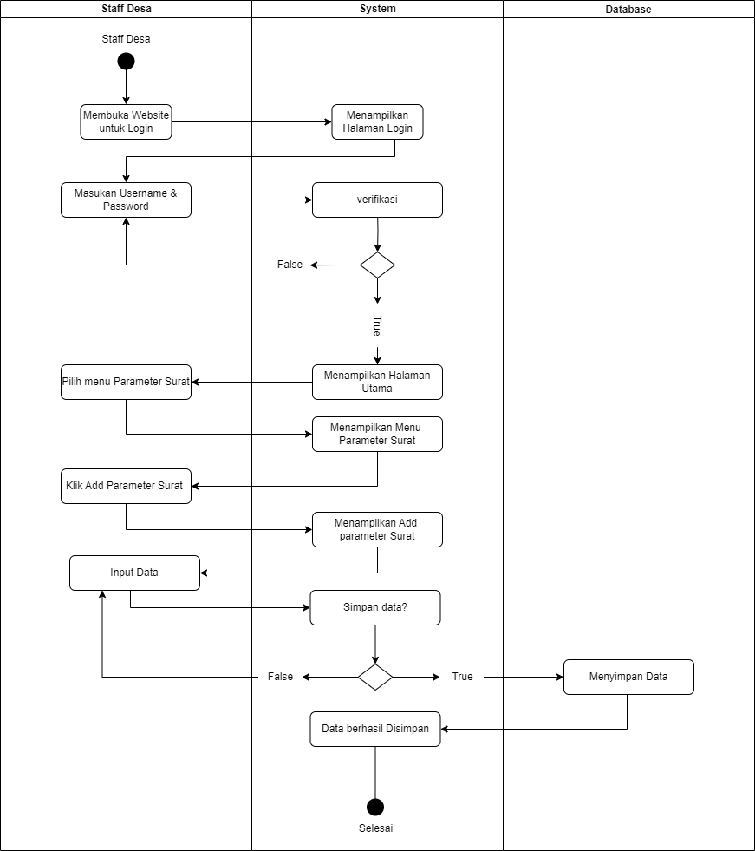

Gambar 4.3 Activity diagram membuat parameter surat

## Activity diagram input data surat

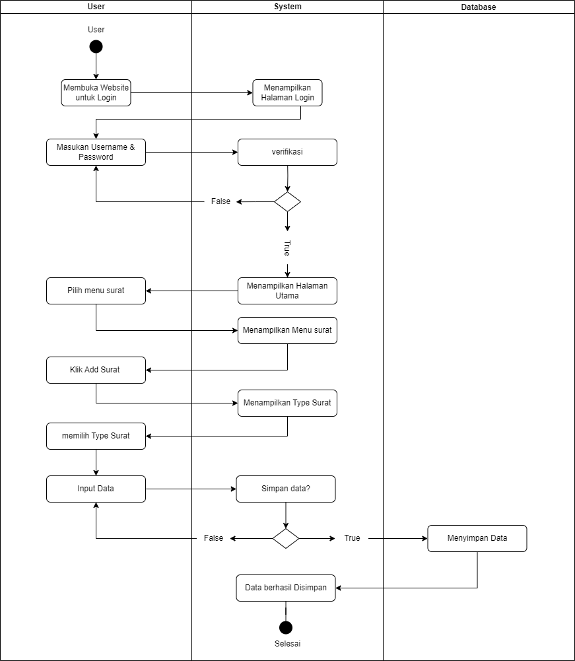

Gambar 4.4 Activity diagram input data surat

## Activity diagram user Print surat ke desa

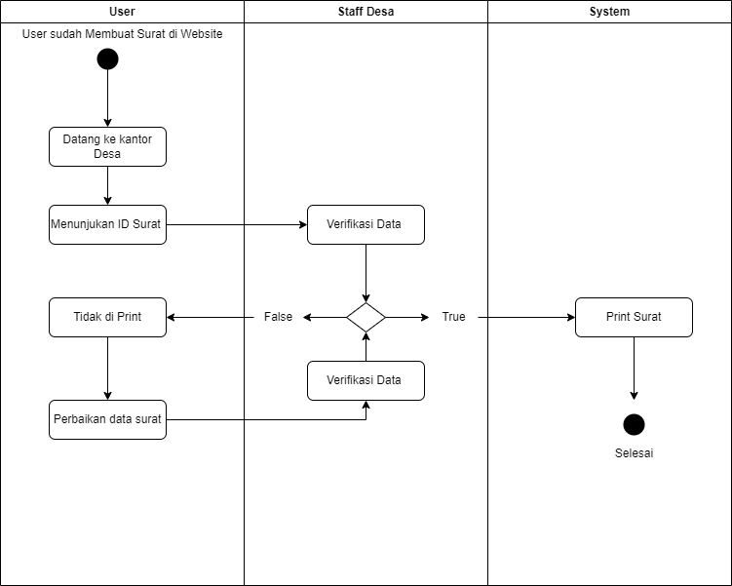

Gambar 4.5 Activity diagram user Print surat ke desa

**Entity Relationship Diagram**

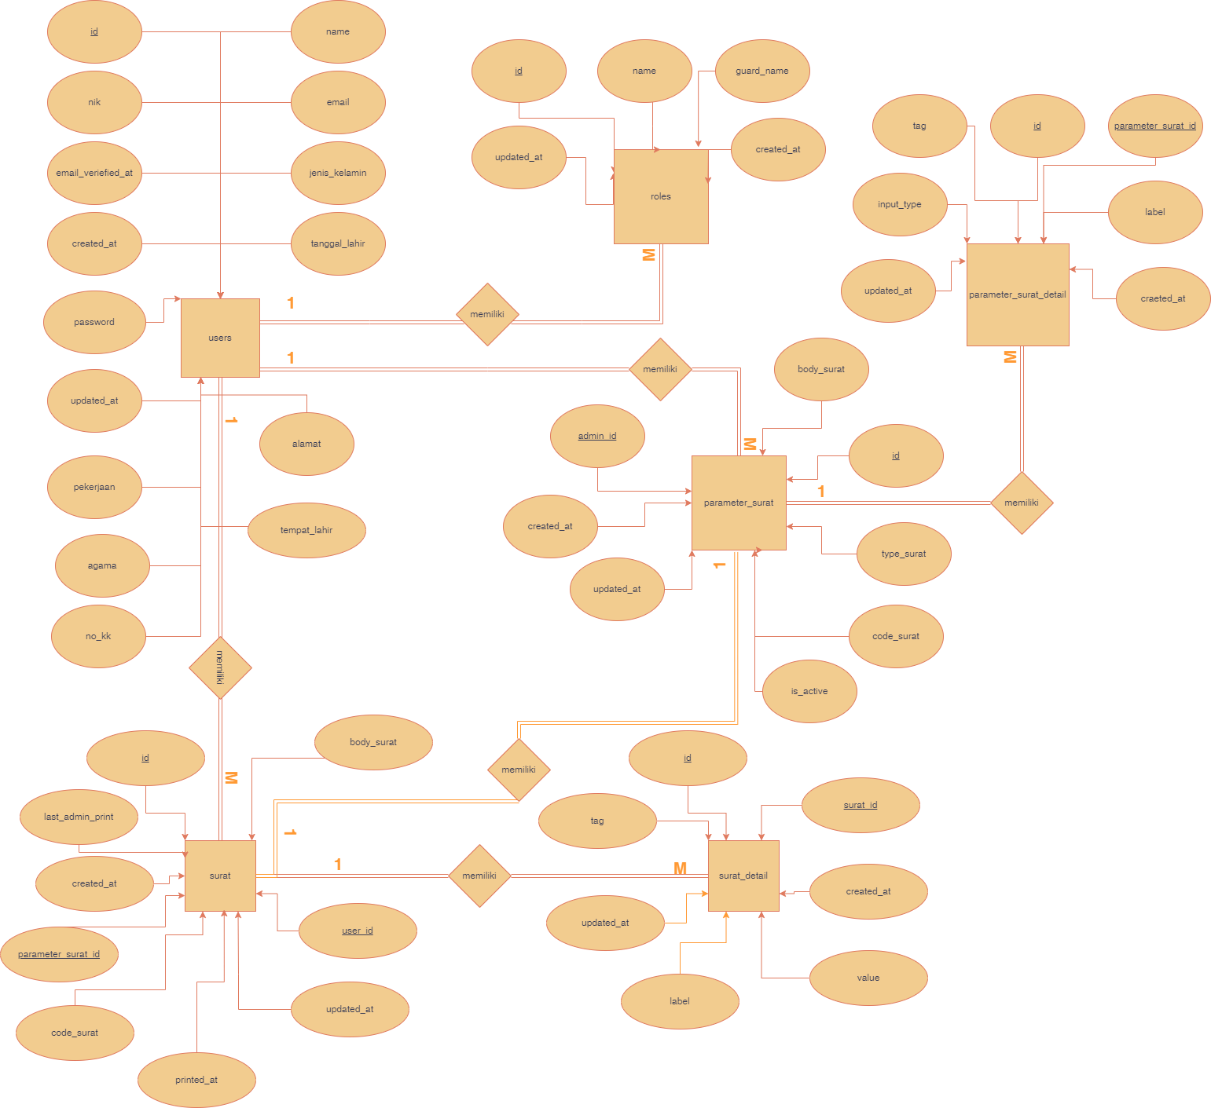

Gambar Entity Relationship Diagram

## Rancangan Database

* 1. **Tabel user**

Spesifikasi File Tabel user

Nama Database :   
Nama File : user

Tipe File : File Master

Random Panjang Record :   
Kunci Field : Id_admin

Tabel 1 Tabel user

|  |  |  |  |  |
| --- | --- | --- | --- | --- |
| # | COLUMN | TYPE | VALUE | DESC |
| 1 | id | bigint |  | * |
| 2 | nik | varchar | 50 | - |
| 3 | name | varchar | 100 | - |
| 4 | email | varchar | 100 | - |
| 5 | email_verified_at | timestamp |  | - |
| 6 | password | varchar | 255 | - |
| 7 | jenis_kelamin | varchar | 20 | - |
| 8 | alamat | text |  | - |
| 9 | agama | varchar | 50 | - |
| 10 | pekerjaan | varchar | 50 | - |
| 11 | tempat_lahir | varchar | 50 | - |
| 12 | tanggal_lahir | datetime |  | - |
| 13 | no_kk | varchar | 50 | - |
| 14 | created_at | timestamp |  | - |
| 15 | updated_at | timestamp |  | - |

## Tabel parameter_surat

Spesifikasi File Tabel parameter_surat

Nama Database :   
Nama File : parameter_surat

Tipe File : File Master

Random Panjang Record :   
Kunci Field : Id_ parameter_surat

Tabel 2 parameter_surat

|  |  |  |  |  |
| --- | --- | --- | --- | --- |
| # | COLUMN | TYPE | VALUE | DESC |
| 1 | id | bigint |  | * |
| 2 | body_surat | varchar | 30 | - |
| 3 | created_at | varchar | 100 | - |
| 4 | admin_id | int | 11 | - |
| 5 | updated_at | timestamp |  | - |
| 6 | is_active | varchar | 10 | - |
| 7 | type_surat | varchar | 100 | - |
| 8 | code_surat | varchar | 100 | - |

## Tabel parameter_surat_detail

Spesifikasi File Tabel parameter_surat_detail  
Nama Database :   
Nama File : parameter_surat_detail   
Tipe File : File Master

Random Panjang Record :   
Kunci Field : Id_ parameter_surat_detail

Tabel 3 Tabel parameter_surat_detail

|  |  |  |  |  |
| --- | --- | --- | --- | --- |
| # | COLUMN | TYPE | VALUE | DESC |
| 1 | id | bigint |  | * |
| 2 | parameter_surat_id | int | 11 | - |
| 3 | label | varchar | 100 | - |
| 4 | tag | varchar | 50 | - |
| 5 | input_type | varchar | 50 | - |
| 6 | created_at | timestamp |  | - |
| 7 | updated_at | timestamp |  | - |

## Tabel surat

Spesifikasi File Tabel surat  
Nama Database :   
Nama File : surat

Tipe File : File Master

Random Panjang Record :   
Kunci Field : id_surat

Tabel 4 Tabel surat

|  |  |  |  |  |
| --- | --- | --- | --- | --- |
| # | COLUMN | TYPE | VALUE | DESC |
| 1 | id | bigint |  | * |
| 2 | body_surat | text |  | - |
| 3 | last_admin_print | int | 11 | - |
| 4 | created_at | timestamp | 30 | - |
| 5 | parameter_surat_id | int | 11 | - |
| 6 | code_surat | varchar | 100 | - |
| 7 | printed_at | timestamp |  | - |
| 8 | updated_at | timestamp |  | - |
| 9 | user_id | int | 11 | - |

## Tabel surat_detail

Spesifikasi File Tabel surat_detail  
 Nama Database :   
Nama File : Tabel surat_detail

Tipe File : File Master

Random Panjang Record :   
Kunci Field : Id_surat_detail

Tabel 5 Tabel surat_detail

|  |  |  |  |  |
| --- | --- | --- | --- | --- |
| # | COLUMN | TYPE | VALUE | DESC |
| 1 | Id | bigint |  | * |
| 2 | surat_id | int | 11 | - |
| 3 | tag | varchar | 50 | - |
| 4 | created_at | timestamp |  | - |
| 5 | updated_at | timestamp |  | - |
| 6 | label | varchar | 100 | - |
| 7 | value | text |  | - |

## Table roles

Spesifikasi File Tabel roles  
Nama Database :   
Nama File : roles

Tipe File : File Master

Random Panjang Record :   
Kunci Field : Id_roles

‘

Tabel 4.9 Tabel Cost Delivery

|  |  |  |  |  |
| --- | --- | --- | --- | --- |
| # | COLUMN | TYPE | VALUE | DESC |
| 1 | id | int | 11 | * |
| 2 | name | varchar | 11 | - |
| 3 | guard_name | int | 255 | - |
| 4 | created_at | timestamp |  | - |
| 5 | updated_at | timestamp |  | - |